-

**DAB304 004- HEALTHCARE ANALYTICS**

FINAL PROJECT REPORT

***Topic: Hospital Charges for Inpatients***

Prepared by

Group Members:

* Ashu Walia (ID:0734326)
* Bency Eldho (ID:0731915)
* Kanchan Bagga (ID: 0732356)
* Sonia Sonia (ID: 0731611)
* Sukhamanpreet Kaur (ID: 0734303)

***HOSPITAL CHARGES FOR INPATIENTS***

How inpatient hospital charges can fluctuate among different providers inside the US? This project will display you how the price for the similar diagnosis and the same treatment and within the same city can vary in a different way across dissimilar providers. It may assist you or the one you love to discover a better clinic for the treatment. You can also examine to detect fraud amongst providers.

1. **INTRODUCTION**:

Total health care spending in America became $3.5-trillion in 2017 and about 32% of that amount($1.1-trillion) was spent on hospital services. Hospital expenses averaged $3,949 per day and each hospital stay cost an average of $15,734. These are shocking figures, especially for households with restricted budgets or no insurance. It is not amazing that 60% of all bankruptcies are associated with clinical charges. One thing is confident that Health care is a big business.

There is no trendy machine that determines what a health center charges for a specific carrier or procedure. Many factors determine into health center pricing, consisting of a man or woman’s fitness situations, the fee of lab checks, X-rays, surgical techniques, operating room and post-surgical fees, medicinal drugs, and docs’ and experts’ costs.

For example, if one patient’s recovery takes place in an Intensive Care Unit (ICU) and another patient’s recovery in a recovery room, their charges can differ by thousands of dollars, even though the two patients’ surgical treatment were similar. Moreover, total hospital costs vary significantly depending upon where a hospital is situated and who winds up paying the bill such as the patient, an insurance company or a government program such as Medicare or Medicaid.

“Rising health care costs for hospital stays and surgeries have created a new financial and emotional epidemic for Americans,’’ said Gail Trauco, an Atlanta-based oncology nurse who also serves as a pharmaceutical trials expert and a licensed grief mediator.

No two hospitals are likely to be the same. So regardless of a hospital’s published fee schedules for a service or procedure, the best information that a prospective patient can receive is a good-faith estimate. Until the bill is actually processed, there is no reliable way to assess a patient’s final hospital costs.

The U.S. has higher prices for most health care services and prescription drugs, according to available internationally comparable data. On average, other wealthy countries spend half as much per person on healthcare than the U.S. So, in order to analyze the impact in detail we selected this dataset.

Inpatient care refers to medical treatment that is provided in a hospital or other facility and requires at least one overnight stay. Inpatient care is broken into two parts: the facility fee and those related to the surgeon/physician.

This dataset will provide the variation of hospital charges in the different hospitals in the us for the top 100 diagnoses. The dataset is owned by the US government, which will show you how price for the same diagnosis and the same treatment and in the same city can vary differently across different providers. This dataset will allow us to do the exploratory analysis of some aspects of the 2014 hospital charge, paying particular attention to this dataset sheds on differences in healthcare market transparency across the country.

1. **RELATED WORK:**

A study describes how, if Maryland had not adopted their unique system, "hospital spending would have been cumulatively $40 billion higher than what resulted under rate setting. On the other hand, had the nation’s costs grown at Maryland’s rate of growth, cumulative savings would have exceeded $1.8 trillion." Despite Maryland's innovation in rate-setting, it is still dealing with the issue of increasing patient volume in hospitals (particularly admissions and out-patient visits) - yet another challenge facing the entire country's entire healthcare marketplace.

1. **METHODS:**

This dataset will provide the variation of hospital charges in the different hospitals in the US for the top 100 diagnoses. This dataset will show you how price for the same diagnosis and the same treatment and in the same city can vary differently across different providers.

This dataset contains 163065 rows and 12 columns

The dataset includes the following columns:

* **DRG Definition:** A description of one of the 100 most common diagnostic resource groups
* **Provider Id:** The numerical identifier for a specific hospital
* **Provider Name:** The name of the same hospital
* **Provider Street Address:** The street address of the same hospital
* **Provider City:** The city where this specific hospital is located
* **Provider State:** The state where this specific hospital is located
* **Provider Zip Code:** The zip code where this specific hospital is located
* **Hospital Referral Region (HRR) Description:** The Hospital Referral Region (regional health care market for tertiary medical care) where this specific hospital is located.
* **Total Discharges:** The total number of patients who were released from this specific inpatient hospital after receiving care related to this specific DRG.
* **Average Covered Charges:** The amount of money charged by the hospital for this medical procedure (how much the provider charges to Medicare).
* **Average Total Payments:** The amount of money received by the hospital for this medical procedure (This includes the reimbursement from Medicare, as well as third party payments for coordinating benefits, and any co-payment)
* **Average Medicare Payments:** The amount of money that Medicare has reimbursed to the hospital for this medical procedure.

Initially Based on the dataset we are planning to find out the answer for some of the business questions given below:

* Which are the most expensive treatments from the entire list
* Which are the most expensive treatments with regard to each state?
* Which is the most common DRG with respect to the number of discharges?

Due to large number of data we then concentrate more on particular diagnosis so that we can visualize it better. We used Excel & Tableau mostly for the analysis. We included 2 additional columns. One is ‘average charges for inpatient’ to get how the providers are charging patients for a particular diagnosis. It is calculated by taking the difference between average covered charges and average total payment. Second one is the ‘average charge per patient’ so that will get an idea of how much per person is charged for the diagnosis. It is calculated by dividing average charges for inpatient with the total discharges.

1. **RESULTS:**

For better visualization we only took top/bottom 10 from the list add did analysis based on the charges per inpatient

4.1 **Most Expensive Treatment**

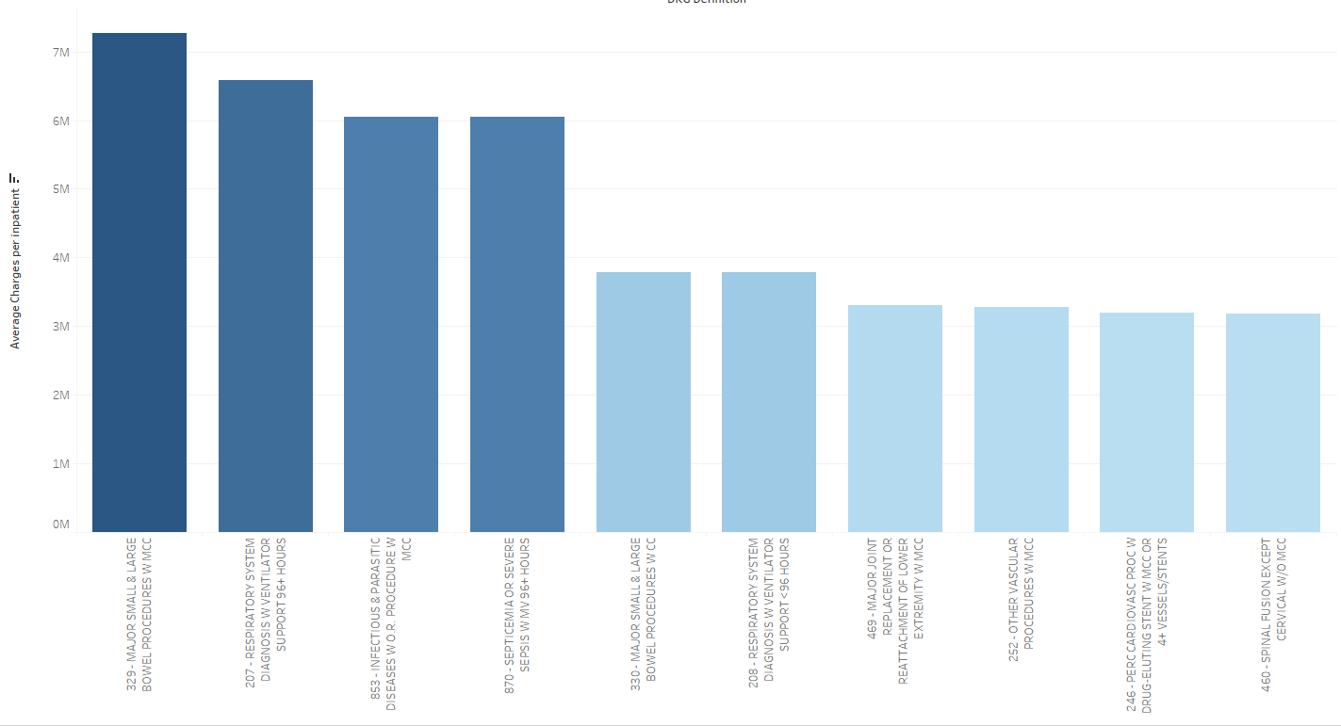

From the entire list, **DRG 329(329 - MAJOR SMALL & LARGE BOWEL PROCEDURES W MCC)** is the expensive treatment.

* 1. **Cheapest Treatment**

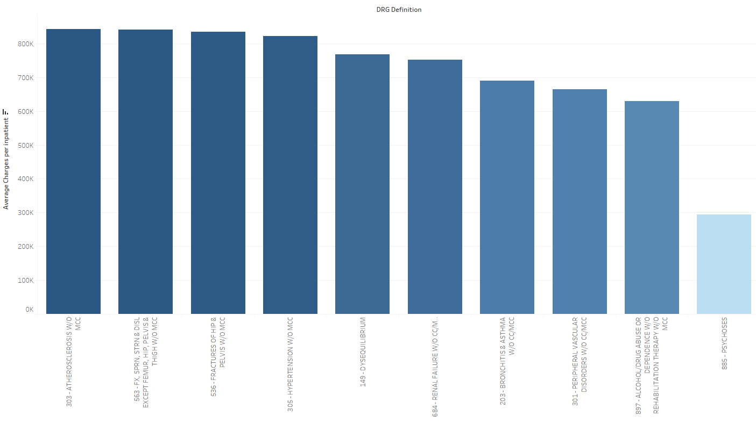

If we consider the cheapest treatment, we found that **DRG 885 – PSYCHOSES** have the least expenses from the list.

* 1. **Expensive Treatment with respect to top 5 highest charges state**

Next thing we looked is that out of the given states, which state has the highest price and found CA has the highest rate followed by Florida, Texas in all of these top 10 most expensive treatment. For more understanding we just took 2 most expensive treatment **(DRG-320 & DRG-207)** and compare the rate of it across the states. So, we found that a huge variation for the same diagnosis across the states. It may be because of the what provider is charging, which will be further analyze in the next stage.

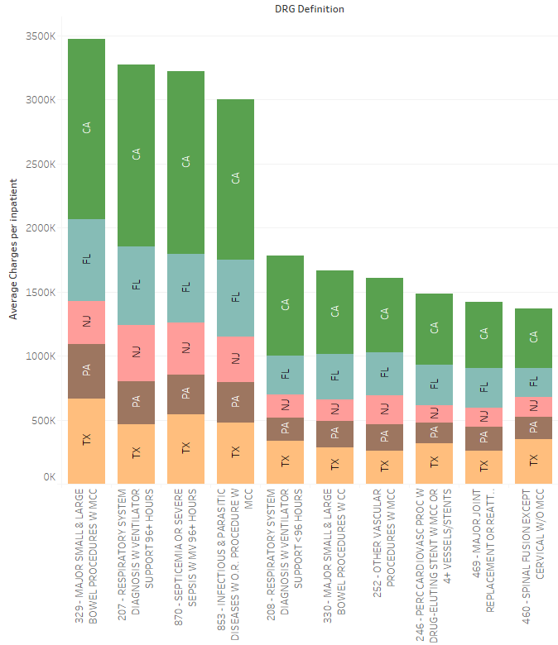

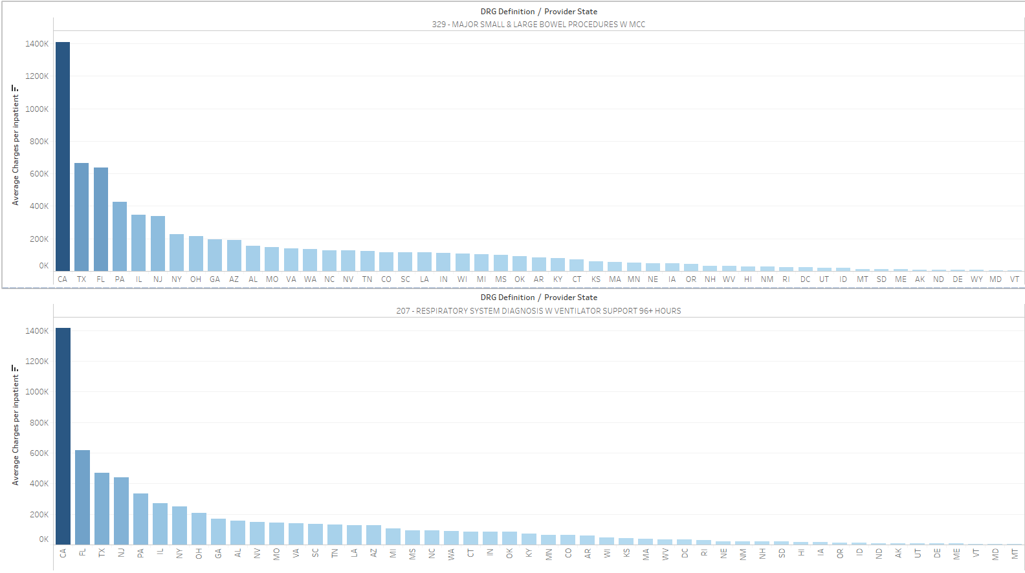

* 1. **Most Common DRG’s**

From the below visualization we found that taking all the diagnosis is not a better strategy to move on so decided to find out a particular procedure which is frequently occurred which is found out based on total discharges. **470 - MAJOR JOINT REPLACEMENT OR REATTACHMENT OF LOWER EXTREMITY W/O MCC** is one which is we found from the analysis. For further analysis we took only data regarding DRG-470 for our analysis.

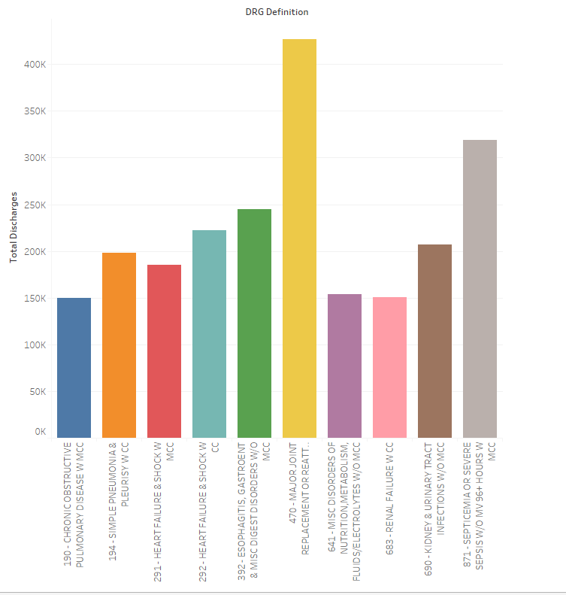

* 1. **DRG 470 Charges by State**

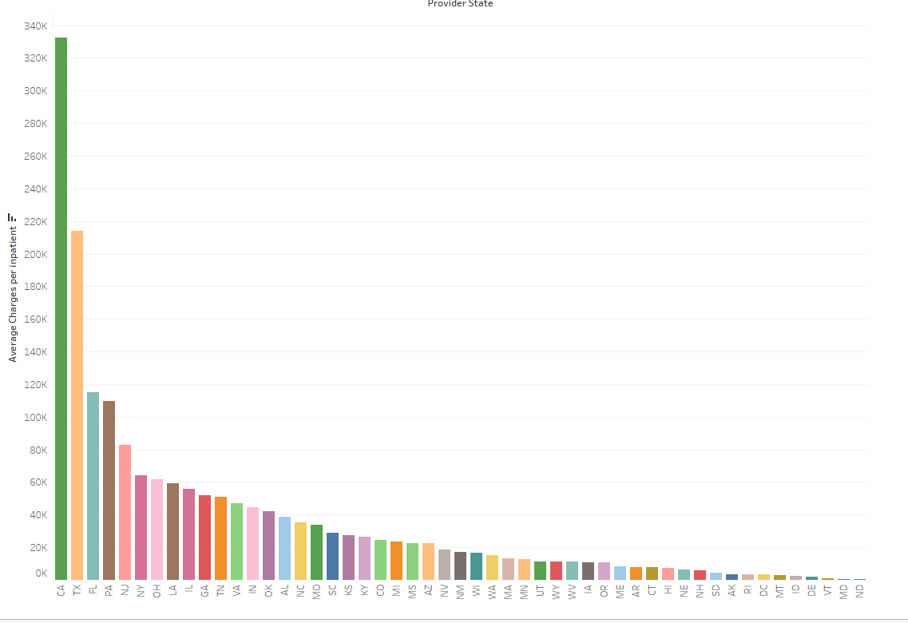

From the above analysis we found that there is a huge variation in the price in CA when compared with others. It may be because of some error in values. When we further investigated, we found that there is almost 439 hospitals and population also here is high (39557045) when compared to other states and may be because of that California is charging highest rate. Also, if a state has more population, chances of having health problems is also high and more patients will go to hospital for treatment and thus if more patient then obviously hospital has a tendency for charging more for each treatment.

If we consider the cheapest state Maryland is one which charges less for DRG-470.We found that Maryland has only 72 Hospital and population is also less (6,042,718). Maryland is the only state which has a central government body that sets standardized payment rates for hospital procedures, across all public and private insurance plans. So, may be because of that their hospital charges are less when compared to others.

**4.6 Comparison of Hospital Charges and Medicare Payments in California and Maryland**

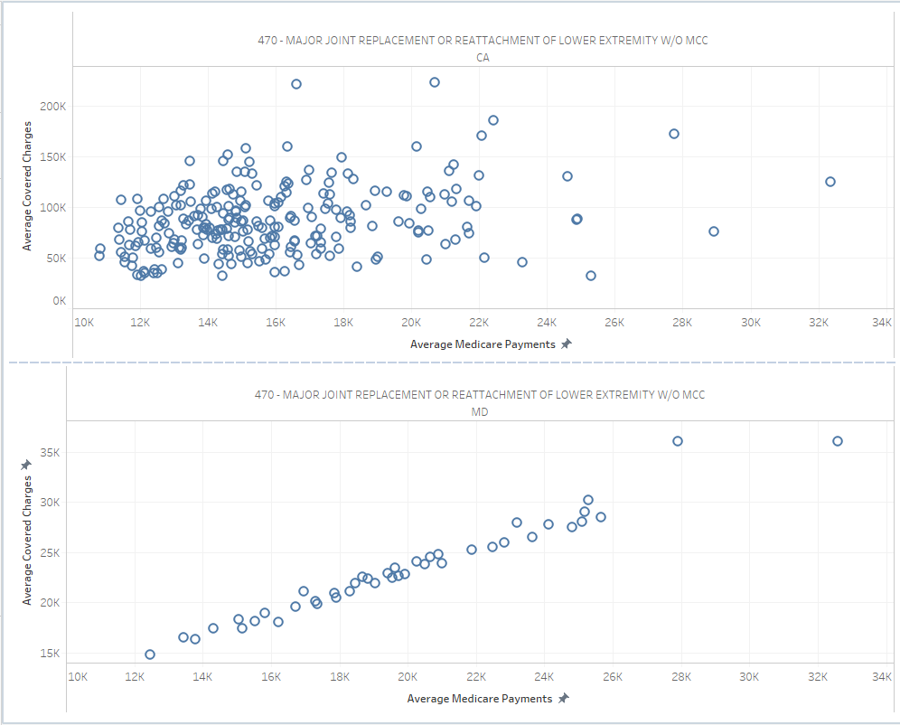

From the above analysis we found that California is charging highest and Maryland is charging less for DRG-470. So just to compare how the covered charges & Medicare payment is related in both states, we did another visualization. From the first scatterplot we can see that Medicare payment amounts for these procedures are most often between $10,000 and $20,000, whereas hospital charges tend to be most often between $50,000 and $150,000. The result of these marked up hospital charges is shown in the heavily skewed clusters on the scatter plots above. DRG 470 procedures appear to be an example of the lack of price transparency that healthcare consumers or industry analysts would find in the California marketplace, and many other healthcare markets across the country. But for Maryland we can see most evenly distributed collection of hospital charges. These charts appear to depict a very different relationship from the one visible for California's data. We can see an almost one-to-one relationship between hospital charge amounts and average Medicare payments in Maryland.

It turns out that Maryland's data for hospital charges is quite unique in comparison to the rest of the states because Maryland is the only state which has a central government body that sets standardized payment rates for hospital procedures, across all public and private insurance plans.

This system was set up in 1971 in reaction to rising hospital costs and large losses incurred by treating uninsured patients. The centralized rate-setting system has created a transparent marketplace for consumers and kept growth of hospital costs below the national trend.

* 1. **Comparison of Charges of various providers in State CA & TX**

Since we are not sure about the details of CA state for better generalization, we took 2 states CA and Texas for our analysis and compare the various hospital charges in the same state. We found that within the same state different providers are charging different rate.

* 1. **Correlation between Hospital charges and Medicare payment**

From the above analysis we found that there is a huge variation in average charges with respect to different providers. So, we just check whether there is any impact on Medicare charges with respect to these variations. We found that there is also some huge variation for Medicare payment for the same services within the same state. For example, the average Medicare payments for DRG -470 ranged from about $32k to about $10k in California and from about $25k to $7k in Texas.

There is a positive correlation between what a hospital is charging and what they are paid by Medicare. According to our analysis, correlation between average covered charges and average Medicare payments is 0.77(Used the Formula: =CORREL (J2:J163066, L2:L163066))

* 1. **Creating Indicator based on the average charges**

As a final step, we just created a baseline/indicator to find out the provider which is charging more than the average covered charges. Since there is positive relationship between covered charges and other variables, we did the analysis based on a baseline which is the average value of the covered charges.

We found that for both states, many hospitals are charging more money than the average charge. This may be because of the usage of advanced tools and techniques, facilities and so on. As a generalization we can say that there is no standardization of charges. Since this covered charge is related to the average charge for inpatient, some hospitals are charging more money to the patients and thus making a lot of benefits from this industry.

1. **DISCUSSION**

Our main goal is to check how the charges are varying with respect to diagnosis, state, providers and we achieved it while doing the analysis. We compared the results with other researches and also their results are somewhat similar, but they did in different way but as a conclusion our results are in line with what they reported.

Initially, it was very difficult to start the work since we have almost 16k rows, 100 diagnosis, 50 states. The providers are different for each state, so it was difficult to categorise. Also, while doing visualization it was difficult to see the entire list in order to get the correct details regarding the highest and smallest charges. So, we decided to concentrate more on one particular diagnosis and decided to take that has the most common DRG’s which is the DRG-470.In that way we overcame our challenges regarding the dataset and reached our conclusion correctly.

1. **CONCLUSION**

There are almost 163033 records so difficult to analyze the entire list. So, decided to concentrate more on specific diagnosis so that will analyze it clearly and we can make that as a conclusion for the entire diagnosis.

In the above analysis, we took a look at how the relationship between hospital charges and Medicare payments differed across the country in 2014, particularly for procedures related to the most common DRG (470 - Joint Replacement/Lower Extremity Reattachment). There is no standard system that determines what a hospital charge for a particular service or procedure.

The result will help us to provide the view of the distortions and lack of transparency for consumers in most of the U.S. healthcare market.

1. **CONTRIBUTIONS**

Building and keeping a good team is essential to the success of or project and makes our own job easier. Everyone participated equally to find out the datasets. The duties such as finding the dataset, exploring it, finding out valuable insights, documentation etc. were done in such a way that all the team members have the same amount of workload.

1. **REFERENCES**

* <https://www.kaggle.com/speedoheck/inpatient-hospital-charges>
* <https://data.cms.gov/Medicare-Inpatient/National-Summary-of-Inpatient-Charge-Data-by-Medic/b6z8-hfqs>
* <https://github.com/nmulani/medicare-data-analysis>
* <https://www.cms.gov/Research-Statistics-Data-and-Systems/Statistics-Trends-and-Reports/Medicare-Provider-Charge-Data/Inpatient2011.html>

1. **APPENDICES**

Some of our findings rather than the above mentioned above:

* Found from google about how the total health expenditure per capita varying across different countries.US people are spending highest amount of money for health care.

